Electronic tuning fork

By E Major.

A a - Introduction

I am learning to play guitar but unfortunately I do not have perfect pitch and so I have problems in tuning the strings to the correct notes. Once I have one of the strings tuned to the correct note then I can tune the rest of them. I use a tuning fork to set the frequency of the highest frequency string, but I find this difficult because the sound is quite quiet. I am therefore going to make an electronic tuning fork which will have the correct frequency for the highest frequency which is a note E.

A b - Research

In order to build my electronic tuning fork I need to find out the frequency of the strings of the guitar and also to find out if there are any commercial products that do a similar job from which I can gain ideas.
I started by using Google to search for ‘guitar string frequencies’ and found the reference below.
http://ffden-2.phys.uaf.edu/211.web.stuff/billington/main.htm
There are six strings on a guitar, each with open notes of E2, A2, D3, G3, B3, and E4, each with corresponding frequencies of 82 Hz, 110 Hz, 147 Hz, 196 Hz, 247 Hz, 330 Hz

From this I now know what frequencies I need to tune each guitar string.

The next research I carried out was to see what ‘guitar tuners’ were available using Google.
The first site I visited was http://www.guitarforbeginners.com/onlinetuner.html which had an online guitar tuner. This will be useful to help me test whether my electronic tuning fork is successful after I have completed building it.
I then looked at the Korg GA-1 Digital Guitar & Bass Tuner in Google products
http://www.google.co.uk/products/catalog?q=Korg+GA-1+Digital+Guitar+%26+Bass+Tuner&hl=en&bav=on.2,or.r_gc.r_pw.,cf.osb&biw=1280&bih=571&wrapid=tlif132122015981210&um=1&ie=UTF-8&tbm=shop&cid=8064289845938200763&sa=X&ei=WTjATqyPBI6AhQeigL26BA&ved=0CF0Q8wIwAA#
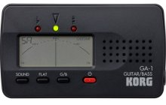
This has the facility to tune each string individually and gives display showing how far out of tune a string is.
While this would be very useful I do not know how I would start to build such a device.

I then searched for ‘electronic tuning forks’, but it would appear that they do not exist as I found no links. However I did find the following at
http://www.thestringzone.co.uk/categories/electronic-tuners-and-tuning-forks

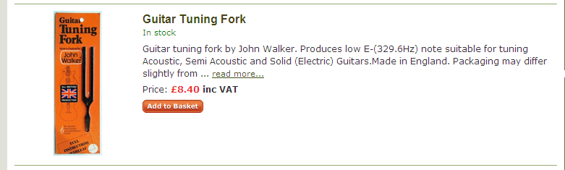

This indicated the exact frequency that I needed for my tuning fork.

A c - Practical Investigations

1. How Long Should the Sound Last?

The sound from a metal tuning fork decays quite quickly, meaning that you have to work quickly when tuning. I decided to measure how long the note from a metal tuning fork was loud enough to be useful when sounded and the stem touched onto a bench.
This was quite subjective but I found that the sound was useful for tuning for about 5-6 seconds after the tuning fork’s stem was touched onto the bench. It did depend a little on how hard the tuning fork prongs were struck and how loud the surrounding noise was.

2. How Loud Should the Sound Be?

I also decided to measure how loud the sound from the metal tuning fork was using a Decibel meter. Again this was very variable as it depended on how hard I struck the metal tuning fork, but I made five measurements with the Decibel meter at a distance of 30cm from the tuning fork on the bench. The results are shown in the table below.

58dB | 64dB | 56dB | 65dB | 68dB

Since one of my problems with using a metal tuning fork is that it is often not loud enough, the above measurements will give me a guide as to how loud to make my electronic version

Ad, e and C a – Specification and Test Planning

I intend producing a battery operated electronic tuning fork which will sound the frequency of the thinnest string of a guitar for a set time when a button is pressed. The electronic tuning fork must be small and portable and must produce a not at least as loud as that produced by a metal tuning fork. It must also not change its frequency as the battery voltage changes or the temperature changes.

Specification Value Testing
Supply voltage range:- 7 – 10V Test with a multimeter.
Frequency:- 329.6Hz + 2Hz Test with an oscilloscope.
Loudness:- 70 – 75dB at 30cm Test with a sound level meter.
Quiescent supply current:- <20mA Test with a multimeter.
Operating current:- <200mA Test with a multimeter.
Sounding time:- 5 – 6s Test with a stopwatch.

System

I believe that I will need to construct the subsystems shown in the diagram below, as this should give me the results that I have specified.

A f - Alternative Ways to Build It
A g - Chosen Solution

There are several different ways in which I can implement each of the subsystems and I am now going to consider each in turn.

Trigger.
I can use either a push button switch or a touch switch. The trigger switch must be reliable and be capable of operating many times. A touch switch has the advantage that there are no real moving parts and so there could be less to go wrong. However, a touch switch is going to rely on direct contact with my fingers and so will become dirty with time and use, possibly making the switch unreliable. A mechanical switch, e.g. like those used in computer mice, seem to be very reliable and can withstand frequent ‘clicking’. I will therefore use a switch similar to those in a computer mouse.

Monostable.
I could use a monostable made from two NAND gates or a monostable made from a 555 timer IC. I have recently covered 555 timers in my class lessons and so feel more confident in using these ICs than NAND gates.
NAND gate monostable circuit – IKES ELE2 Support booklet
The formula for the time period of a 555 timer seems to be more accurately defined than the equivalent formula for the NAND gate circuit. However, a disadvantage of a 555 timer IC is that it takes much more current than a NAND gate circuit, and so could be beneficial if battery life becomes an issue. Because of the facility to accurately calculate the time period of a 555 timer monostable circuit, I will use this in preference to the NAND gate monostable circuit.

Astable.
I could use an astable made from two NAND gates or an astable made from a 555 timer IC.
NAND gate astable circuit – IKES ELE2 Support booklet

The advantages and disadvantages of the 555 astable compared with the NAND gate astable are much the same as for the monostable, but with the added advantage that, according to my supervisor, the frequency of a 555 timer IC astable is independent of the supply voltage, and so will not change as the battery becomes discharged. This is a definite advantage and so I will use a 555 timer IC astable.

Driver.
For the driver circuit, I have several options.
A 555 timer IC will supply up to 200mA and so should be adequate for driving a small 8Ω speaker. To limit the current flowing and so not overload the 555’s output, I would need to put a resistor in series with the speaker. This could cause the sound level to be too quiet.
I could use a transistor as a driver. Looking through the Rapid Electronics web site, I found that a BD131 transistor will handle a peak current of more than 1A, which is what I might need to operate the speaker. The transistor will need quite a lot of base current to make it switch this current and so I will need to connect a resistor between the output of the 555 timer IC and the base of the transistor.

I could also use a MOSFET as a driver. The College have quite a lot of these as IRF630s, which according to the Rapid catalogue will switch a current of 8A and need almost no current from the 555 timer IC to operate. They are almost the same price as the BD131 transistors, which would have to be ordered if I was going to use one. Since ordering this through college could take several weeks (according to my supervisor), I have decided to use an IRF630 MOSFET which is already in stock.

Speaker.
I could use for this either a moving coil loudspeaker or a piezo electric sounder. When I researched piezo sounders on Wikipedia, I discovered that they are designed to handle much higher frequencies than I will be using and so I will use a small loudspeaker, of which there are several around the electronics room.

B a, b, c - Subsystem construction.
I am going to build each of my subsystems in turn and test them to ensure that they work correctly.

However, before starting, I need to consider the likely dangers I will encounter and try to minimise them.

B f - Safety and Risk Assessment

Cuts and puncture injuries:- These could occur if I am careless with the wire cutters and strippers and so I must ensure that I am careful and keep my fingers away from sharp surfaces and wires.
Eye injuries:- These could occur from pieces of wire being flipped into my eyes when cutting wires and from components becoming damaged and exploding. To minimise this risk I will wear protection glasses, though the chances of anything exploding when powered by the batteries my supervisor supplies are very low!
Trip hazards:- I will minimise these by ensuring that my work space is clear of clutter and that my bag is well out of the way.
Component and equipment damage:- I will ensure that all equipment I use is firmly on the bench and that there are no trailing wires. I will ensure that all polarised components are correctly positioned, though I suspect that my supervisor’s batteries have so little energy that they would not be damaged anyway.

Trigger subsystem.
Below is the circuit diagram of my trigger circuit, together with a photograph of its construction.

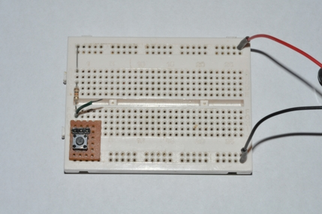

The resistor that I used was not critical and was just to limit current flow when I pressed the switch. I therefore decided to use a 10kΩ resistor, as there are a lot of these in the lab and the current flow will be small.
To test the circuit, I attached a voltmeter to the junction between the switch and the resistor.
When the switch was not pressed, the meter gave a reading of 9.12V and when the switch was pressed the meter gave a voltage reading of 0.02V.
Since this is type of values that I was expecting, I am happy that my trigger circuit is working.

Monostable subsystem.
Below is the circuit diagram of a 555 timer IC monostable, which I obtained from the ELEC2 Support booklet from the IKES web site (URL in bibliography).

B a – Devise Circuit – 2

I need to calculate the components for this to give me a time period of 5 – 6 seconds, as in my specification.
From the ELEC2 Support booklet, the time period is given by the formula

T = 1.1 R C
B b – Calculation – 2
I have decided to use a 10µF capacitor and so

$$R=\frac{T}{1\text{.}1×C}=\frac{5}{1\text{.}1×{\text{10}}^{−5}}=\text{454545}kΩ$$

This resistor value does not exist and so I will use a 470kΩ resistor. It does not matter if the time period is a little over 5s since I have specified that the note should sound for between 5 and 6 seconds.
I decided to put a LED on the output circuit of the 555 monostable so that it would be easy to see when the circuit was timing and also to help me with testing the monostable subsystem.
The circuit diagram of my monostable circuit is shown below with the component values that I used. I initially used a 10nF capacitor from the Control terminal to 0V, but it seemed to have no effect on the circuit whether it was there or not, so I removed it.

To test the monostable circuit, I connected the battery and pressed the trigger switch. Nothing appeared to happen – the LED did not light.

I connected a voltmeter between the pin 3 of the 555 and 0V and pressed the trigger switch again. The meter went from a reading of 0.01V to 8.83V and after a few seconds returned to a reading of 0.00V. I checked my LED circuit and discovered that I had connected the LED series resistor incorrectly. I corrected my fault and pressed the trigger switch again. This time the LED lit and stayed lit for a few seconds.
I repeated the test five times and used a stop watch to time how long the circuit worked for. The results are in the table below.
B c – Testing and Assessment - 2

Time (s) | 5.53 | 5.18 | 5.31 | 5.21 | 5.28
Output (V) | 8.83 | 8.83 | 8.82 | 8.82 | 8.81

This gives an average value of 5.30s, which is well within the range of my specification.

A photograph of the monostable and trigger circuit is shown below. The trigger switch has just been pressed and the LED is lit.

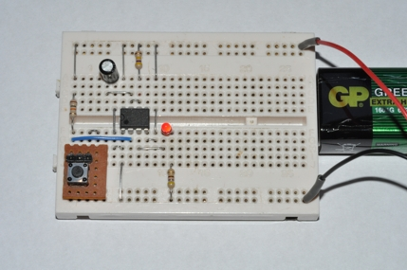

Astable subsystem.
Below is the circuit diagram of a 555 timer IC astable, which I obtained from the ELEC2 Support booklet from the IKES web site (URL in bibliography).

I need to calculate the components for this to give me a frequency of 329.6Hz, as in my specification.
From the ELEC2 Support booklet, the frequency is given by the formula

$$f=\frac{1\text{.}\text{44}}{\left(R_{A}+2R_{B}\right)C}$$

I now need to decide on the resistor and capacitor values. I need to choose two of these and then calculate the third. I have decided to use a 100nF capacitor and can now calculate (R_{A}+2R_{B}).

$\left(R_{A}+2R_{B}\right)=\frac{1\text{.}\text{44}}{\text{329}\text{.}6×{\text{10}}^{−7}}=\text{43689}\text{.}3Ω$

To find values for R_{A} and R_{B} I need to consider what preferred values are available. I chose a 3.6kΩ resistor for R_{A}, which then left me with R_{B} as 20kΩ.
I connected up these values to my astable circuit and connected a digital frequency meter to the output. When I connected the battery, the frequency meter gave a value of 382Hz. This was no where near the frequency I wanted and so I rechecked my calculations and found no errors. I therefore assumed that the tolerances in the resistors and capacitor were causing this problem.
I decided to experiment changing the resistor values and found that a value for R_{A} of 1kΩ and R_{B} of 22kΩ, gave me a frequency of 332Hz. While this is not exactly the value that I wanted, it is near enough, and so final adjustments can be made at the final testing stage.
To make my astable circuit switch on with the monostable circuit, I disconnected pin 4 (Reset) from the power supply and connected it instead to the output of the monostable circuit.
When I pressed the trigger switch, the frequency meter read 332Hz for a few seconds and then returned to a reading of 0.
My final astable circuit diagram is shown below.

A photograph of my circuit so far is shown below.

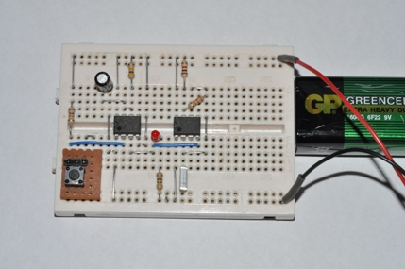

Driver and speaker subsystems.
The circuit diagram of the driver and speaker are shown below.
The loudspeaker I was given to use was a miniature type which was rated at 0.25W. My supervisor advised me to limit the power passing through it by including a series resistor in the circuit. I decided to put a 10Ω resistor in the source lead of the MOSFET, as this would limit the current that could pass through the speaker and also the voltage that was switching the MOSFET on and off.

I added them to the protoboard, connected the battery, pressed the trigger switch and was greeted by a horrid high frequency squeal from the speaker. This was not what I was expecting!!!

I checked my circuit and retested it, but the output from the speaker was the same.
I asked my supervisor if he had any ideas as to what was causing this. He suggested that the speaker was drawing so much current from the battery that the power supply voltage was unstable and interfering with the astable circuit. He suggested putting a small resistor in the power supply lead to the monostable and astable and then connecting a capacitor across the power supply to stabilise the voltage. He would not give me any clue about values, but told me to experiment!

After much frustration I found that a 47Ω resistor in the power supply lead and a 1000µF capacitor across the power supply of the astable, produced the kind of result I was expecting – a loud note at a frequency of 335Hz, which was a little higher than it was when I tested the astable on its own.

B d – How it Works

My full circuit diagram is shown below.
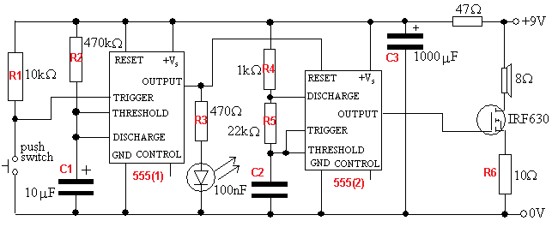

R1 is a pull-up resistor. When the switch is pressed, the voltage drops to zero and the monostable is triggered.
R2 & C1 is a timing circuit. T = 1.1RC. This controls the monostable. C1 charges through R2 until the voltage reaches 2/3 of the power supply. Then C1 is discharged quickly by the 555 discharge transistor.
R3 is a current limiting resistor reducing the LED current to a safe level.
R4, R5 & C2 is a timing circuit for the astable. C2 charges through R4 and R5 until the voltage reaches 2/3 of the power supply. C2 discharges through R5 when the 555 discharge transistor turns on. It discharges until the voltage reached 1/3 of the power supply.
C3 is a decoupling capacitor. It keeps the supply voltage to the circuit steady.
R6 is a current limiting resistor reducing the loudspeaker volume.

B e – Well Organised Layout - This is a photograph of the system before testing.

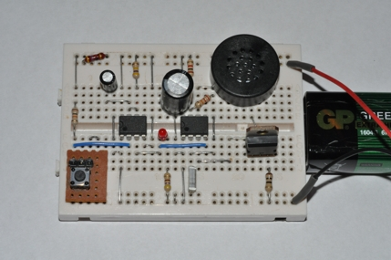

C b, c, d - Whole System Testing and Assessment
With my electronic tuning fork now constructed, I need to decide how to test my complete system against the initial specification I produced.
My initial specification is below and I need to test each parameter.

To test the supply voltage range I will replace my battery with a variable power supply and adjust the voltage between 7V and 10V.
Specification.
Supply voltage range:- 7 – 10V
Frequency:- 329.6Hz + 2Hz
Loudness:- 70 – 75dB at 30cm
Quiescent supply current:- <20mA
Operating current:- <200mA
Sounding time:- 5 – 6s
While doing this, I will measure the quiescent current and operating current by connecting an ammeter in series with my circuit.
For each of my voltage measurements, I will also record the frequency, using the digital frequency meter and the loudness using a sound level decibel meter.
I will also record how long the tuning fork sounds for at each of the different supply voltages.

C a - Test Planning - I will record all of my results in the table below.

Supply voltage (V) | Quiescent current (mA) | Operating current (mA) | Frequency (Hz) | Loudness (dB) | Sounding time (s)
7.0
7.5
8.0
8.5
9.0
9.5
10.0

C b, c - Test Results
I varied the supply voltage and recorded my results below.

Supply voltage (V) | Quiescent current (mA) | Operating current (mA) | Frequency (Hz) | Loudness (dB) | Sounding time (s)
7.0 | 17.1 | 98 | 331 | 74 | 5.21
7.5 | 18.3 | 125 | 331 | 74 | 5.27
8.0 | 20.1 | 140 | 331 | 74 | 5.31
8.5 | 21.7 | 164 | 332 | 75 | 5.34
9.0 | 23.1 | 198 | 332 | 75 | 5.34
9.5 | 24.1 | 223 | 332 | 76 | 5.32
10.0 | 25.2 | 241 | 333 | 76 | 5.41

I also tried to use the system to tune the E string on my guitar, but found that it was not as easy as I expected it to be compared to the metal tuning fork.

C d - Assessment
Looking at the results table above, my system operated over the specified voltage range.
The quiescent supply current was higher than I was anticipating – the 555 timer data sheets suggest that the operating current of a 555 timer are 10mA at 15V, so I assumed that the overall quiescent current would be less than 20mA, but at 9V it was 23mA.
The operating current was also higher than I expected. Although I had specified 200mA as the maximum current, I had expected the actual current to be around 150mA. With a recorded operating current of 198mA at 9V, my system is just within specification.
The frequency of operation is also a little different to my specified value, being 332Hz at 9V instead of 329.6Hz. In practice since I do not have perfect pitch, I guess that for normal jam sessions I will not notice the difference.
The sound level was higher than the minimum I specified, and the extra few decibels louder are an advantage in helping me tune my guitar.
For the time period, I had specified 5s – 6s, and the measured value was around 5.3s, which is well within tolerance.

C e - Limitations

The sound from the speaker seemed harsh and made tuning more difficult than I had expected. I discussed this with my supervisor and he suggested that I should look at the waveform of a tuning fork using a microphone and oscilloscope and then compare it with the waveform of my system.
With the tuning fork, the waveform was smooth, but with my system it had sharp edges. He suggested that I could improve the sound by connecting a capacitor from the gate to source of the MOSFET and a resistor in series with the gate.

C f - Modifications

I experimented with various values and found that a 100nF capacitor and a 1kΩ resistor was a useful improvement in reducing the sharp edges. I incorporated this capacitor into my final system.

I quickly checked my results again with this modification, and the only real effect was that it was not quite as loud as it was before, being only 73dB at 30cm when operating from 9V. However, it was much easier to tune the guitar string.

B f - Safely Build two or more subsystems
B g - Neat Construction
D b - Photographic Evidence

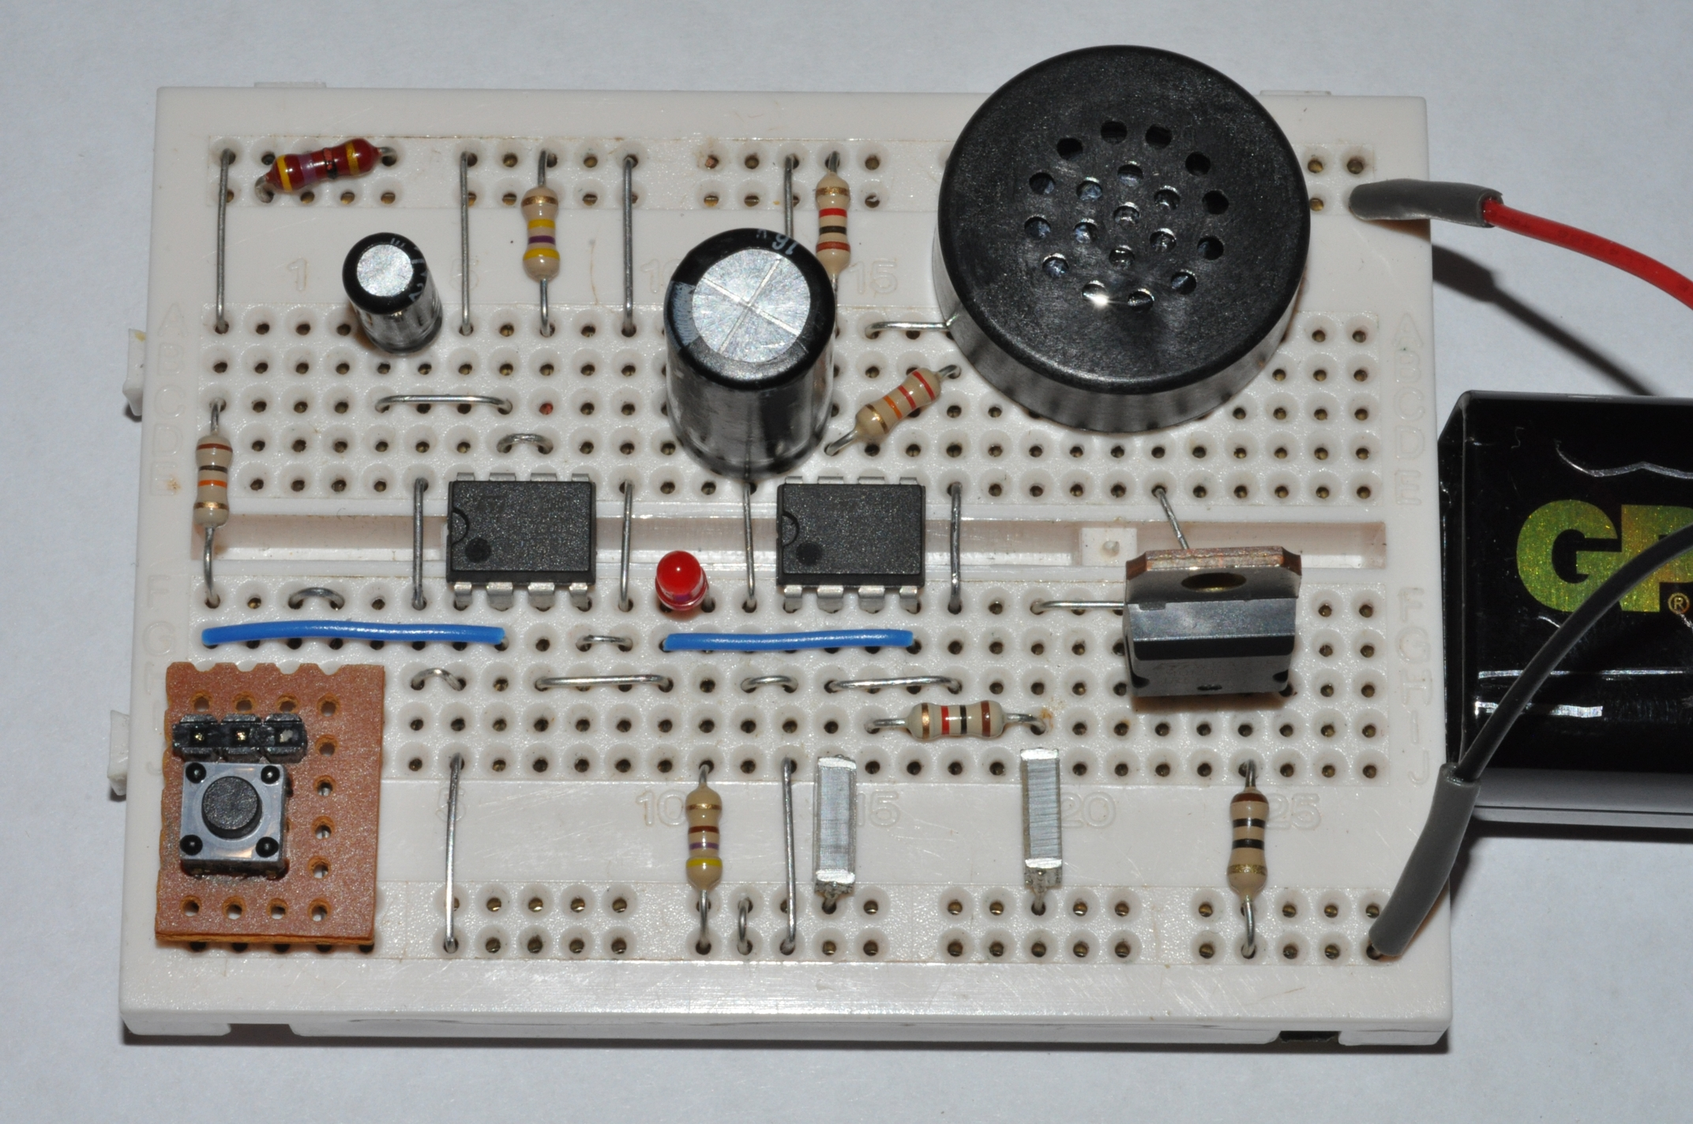

D b - My complete circuit diagram

D c – Bibliography and Help Received

555 Timer Data Sheet  Voltages and Circuit Diagrams | http://www.national.com/ds/LM/LM555.pdf
Frequency of guitar strings | http://ffden-2.phys.uaf.edu/211.web.stuff/billington/main.htm
Online guitar tuner | http://www.guitarforbeginners.com/onlinetuner.html
Korg guitar tuner | http://www.google.co.uk/products/catalog?q=Korg+GA-1+Digital+Guitar+%26+Bass+Tuner&hl=en&bav=on.2,or.r_gc.r_pw.,cf.osb&biw=1280&bih=571&wrapid=tlif132122015981210&um=1&ie=UTF-8&tbm=shop&cid=8064289845938200763&sa=X&ei=WTjATqyPBI6AhQeigL26BA&ved=0CF0Q8wIwAA#
Guitar tuning fork | http://www.thestringzone.co.uk/categories/electronic-tuners-and-tuning-forks
IKES web site | http://www.ikes.freeserve.co.uk
My supervisor | Mr S. Caster

D a – Marks for a well written complete report

